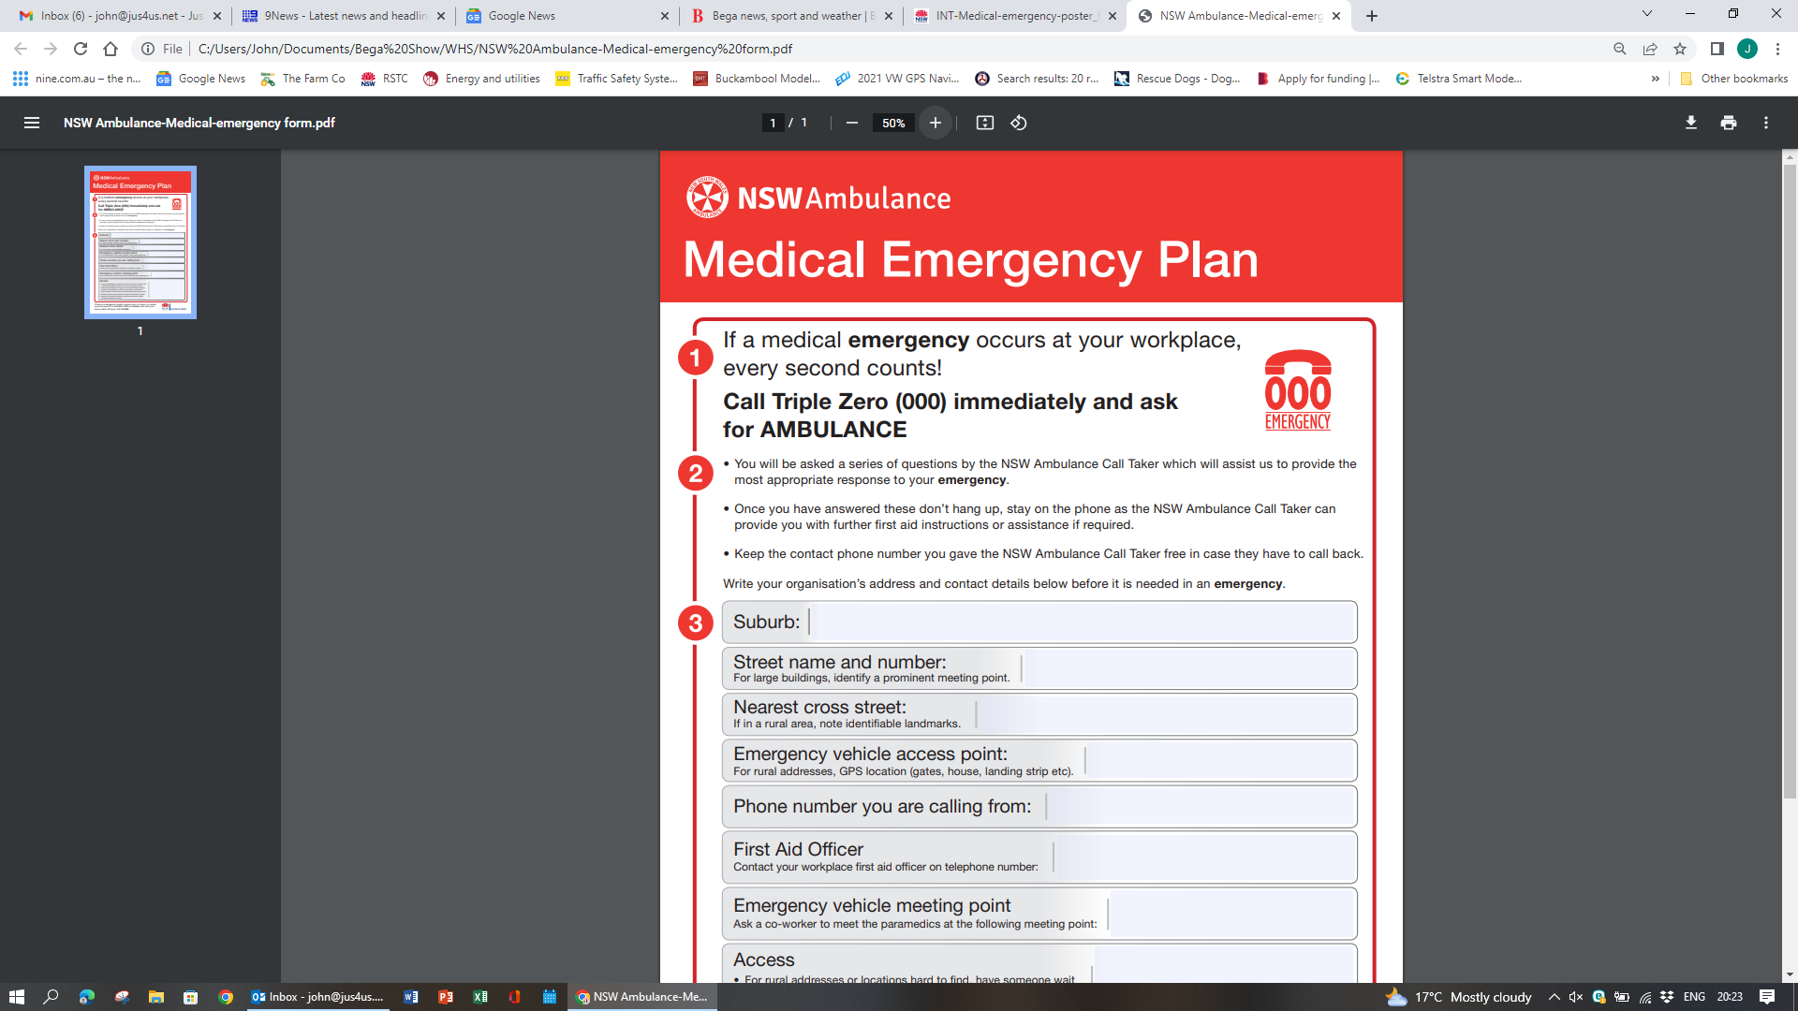

**Bega A.P.& H.**

If a medical emergency occurs **CALL Triple Zero (OOO)**

**Ask for AMBULANCE**

WHS 06



**1**

**2**

**You will be asked a series of questions by the NSW Ambulance Call Taker. See Over**

**Once you have answered the questions, DON’T HANG UP, STAY ON THE PHONE. Call Taker can provide further First Aid Instructions or Assistance if needed.**

**Keep the phone number you gave NSW Ambulance free in case they have to call back.**

**3**

|  |  |
| --- | --- |
| **TOWN** | **BEGA** |
| **Phone Number you are calling from** |  |
| **Location / Street Name** | **Bega Showground, Upper Street** |
| **Nearest Corner or Cross Street** | **Tathra Road** |
| **Best Access Point for Ambulance** | **Use Gate closest to patient location:**  **Main Gate – Upper Street**  **East Gate – Cnr. East St & Tathra Rd.**  **Park Lane Gate – Park Lane** |

**The Call Taker will go into questions about the incident:**

**4**

|  |  |
| --- | --- |
| **What has happened?** |  |
| **How Many Patients?** | **Is the Patient Conscious?**  **Is the Patient Breathing?** |
| **Patients Gender? Age if known** |  |
| **Type of Incident** |  |
| **Any injuries** |  |
| **Any known medical history** |  |
| **Is there a First Aider in attendance?** | **What treatment given?** |

**5**

**The Person who makes the triple zero call, stays with the patient**

**Send a colleague to the nominated Entry Gate to escort Ambulance to scene**